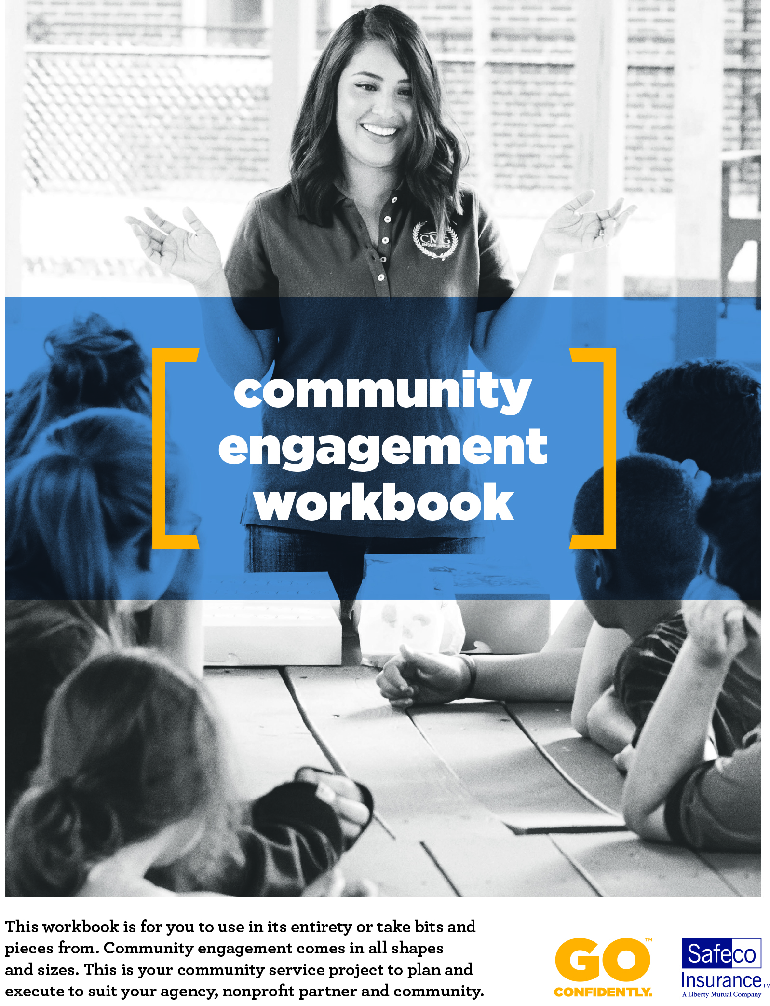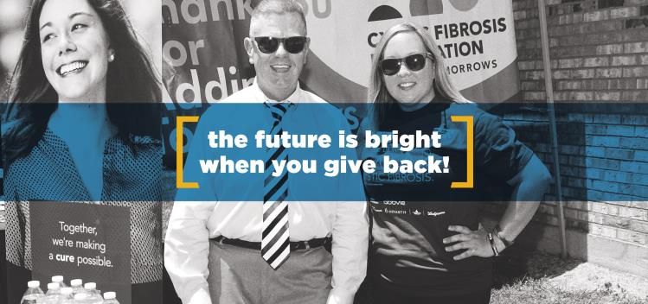

**Amplify your community service with Safeco.** Whether your agency is volunteering for the first time or you already have a deep relationship with a charitable organization, this workbook can help you stay organized, communicate about your impact and keep track of outcomes.

Once you’ve chosen a project, it’s time to get all the details nailed down. Even small details - such as providing accurate directions to the volunteer site and ensuring there’s adequate parking, budgeting for expenses, planning social media posts and follow-up communications and promotions - makes the experience better for everyone involved.

This workbook is for you to use in its entirety or take bits and pieces from. Community engagement comes in all shapes and sizes. This is your community service project to plan and execute to suit your agency, partner organization and community.

In this workbook, you will find:

* Tips for planning your project and rallying volunteers (pgs. 3-5)
* Template for developing your project guide (pgs. 6-9)
* Participation and image release form templates (pgs. 10-11)
* Project planning and day-of checklists (pg. 12)
* Customizable emails and social media posts (pgs. 13-15)
* Project budget worksheet (pg. 16)
* Guide for creating a short story about your volunteer project (pgs. 17-18)
* Community Engagement Detail Sheet – an internal document to track project outcomes (pg. 19)

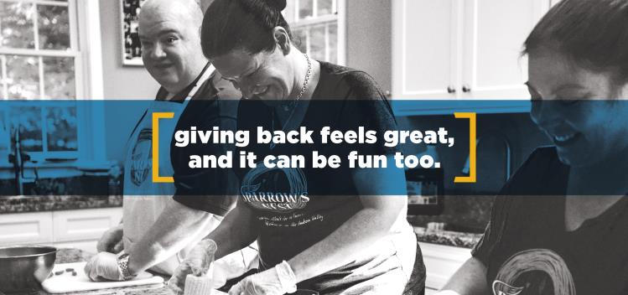

Planning a volunteer project

Whether you’ve already found the right organization and simply need to figure out how to help, or you have a few opportunities with different nonprofits and are trying to choose, here are a few things to keep in mind.

Take these questions to the next staff meeting to start the conversation about how you will all give back, together:

|  |  |
| --- | --- |
| What do your volunteers like to do? |  |
| What skills do your volunteers have? |  |
| What is suitable for the number of volunteers you expect? |  |
| Are there any special requirements for volunteers? |  |
| Most importantly, what does the organization need? |  |

Once the project has been identified, you should use Safeco’s customizable project guide to help you get organized and communicate the goals and logistics of your event. It’s also a great way to make sure that you and the nonprofit are on the same page when it comes to what is expected of the agency, staff and volunteers.

You can find a template for the project guide on pg. 7 of this workbook.

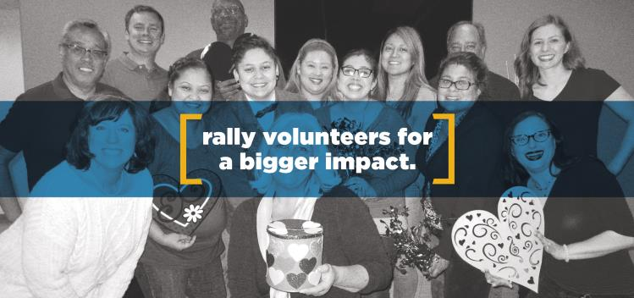

Rallying and preparing volunteers

Once you’ve selected a project, it’s time to get your volunteers lined up — and excited! Here are some tips:

* **Educate prospective volunteers about the organization.** Inspire participation by asking someone from the nonprofit to talk to your co-workers at a team meeting about how your project will help.
* **Invite customers, friends and family members.** If the project needs a large group of participants or donations of goods or funds, don’t hesitate to get more people involved.
* **Make it an all-in effort.** When employees see co-workers, managers and agency owners getting involved, it makes them more likely to offer their support as well. Additionally, when businesses give back - and specifically the CEO of the company - employee motivation to perform increases, as well as their trust in the company, their willingness to stay and their inclination to recommend the company as an employer.[1]

Jotting down a few notes can add clarity for why your agency is getting involved, and help volunteers understand why it’s important:

|  |  |
| --- | --- |
| What is the organization’s mission? |  |
| Why is it important to your community? |  |
| What inspired your agency to get involved? |  |

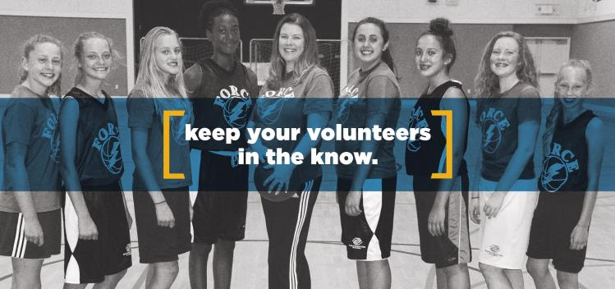

Communicate with your volunteers

Once your team is established, communicate regularly to keep them informed and motivated. Even if all of the volunteers are agency employees, it’s still a good idea to keep them informed via email or other formal communication so there are no surprises when the volunteering or giving project gets underway. Here are recommended messages and posts, and you can find examples of these on page 13 in this workbook:

* “Welcome to the team” email to start people off on the right foot.
* One-month out notice to volunteers to keep them engaged and up to date.
* Two weeks in advance, send the project guide.
* “Thank you” email to volunteers and describe the project’s impact for the organization and the community. Include photos!
* Two weeks after the event, send a final thank you and more details about the project results. You can also create a short survey to ask for input about how to continue the partnership and plan for the next event.

Volunteering can definitely up the “fun factor” at work. Keep the communications going for every volunteer project you do together and drive momentum throughout the year!

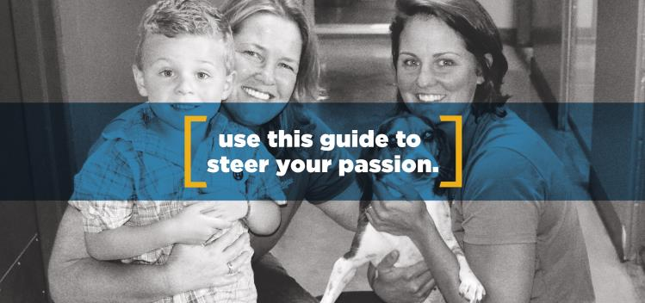

Developing your project guide

This guide should be a collaboration between the agency project leader and the partner organization and will go out to all volunteers with every detail they need.

The more thorough your project guide is, the fewer questions your volunteers will have both before and during the event. That will make things easier for them and for you!

* We’ve included a customizable guide here to help you plan a successful and satisfying project in your community. This can be used for all types of community service projects, from cleaning up a park to running a toy drive or serving dinner at a retirement community.
* Fill out the sections that you need, delete the sections you don’t and brand it for your agency. This is your project to plan how you choose.
* Even if your project doesn’t require volunteer hours, such as a coat drive or referral donation program, your agency will still benefit from having all the details in one place. You can also refer back to the project guide for when you plan future projects.

Insert your company logo here

# Project Guide for [NAME OF THE PROJECT] on [DATE]

**Contact Information**

|  |  |  |
| --- | --- | --- |
| **Project Leader: NAME** | | |
| Email: |  |
| Phone: |  |
| Mobile: |  |
| OK to text? | 🞏 Yes 🞏 No |
| **Nonprofit contact: NAME** | | |
| Email: |  |
| Phone: |  |

**Location & Schedule information**

|  |  |  |
| --- | --- | --- |
| **Project location: NAME OF FACILITY** | | |
| Street address: |  |
| Town/city: |  |
| State: |  |
| Phone: |  |
| **Schedule** | | |
| Please sign in by this time: |  |
| The project will finish at: |  |
| Is there an orientation? | 🞏 Yes 🞏 No |
| Is parking available? | 🞏 Yes 🞏 No |
| Is there a parking fee? | 🞏 Yes 🞏 No |
| Is public transportation available? | 🞏 Yes 🞏 No Routes to location: |
| Initial meeting/check-in location: |  |
| Will restrooms be available? | 🞏 Yes 🞏 No |
| Will a meal or meals be provided for volunteers? Will beverages be available? | 🞏 Yes 🞏 No  Details: |

**Project Details**

|  |  |  |
| --- | --- | --- |
| **Volunteer activities** | | |
| We will be providing the following services for the nonprofit: | ***For example:***   * *Collect recreation equipment for the local Boys & Girls Club* * *Deliver equipment* * *Organize and clean the gym area* * *Build a new organizing rack for the equipment* * *Set up and clean up for the event* |
| How many volunteers are expected to take part? | ***For example:***   * Seven to 10 volunteers for the gym service day * *Aim to collect 50 items to donate to the gym* |
| List task leaders for each project during your volunteer event. | *Copy and paste from above and designate a leader, either at the agency or nonprofit.* |
| Are any specialized skills required for certain duties? If so, please list them and indicate if individuals have been assigned those tasks. | 🞏 Yes 🞏 No |
| Are there requirements regarding age or physical ability to take part in this project? | 🞏 Yes 🞏 No |
| Other volunteer duties: | Food/drinks/snacks:  Photographer:  Other: |
| Additional details: |  |
| **Attire and equipment** | | |
| Is there a chance that clothing will be ruined at this event (painting, etc.)? | 🞏 Yes 🞏 No |
| Do I need to bring work gloves? | 🞏 Yes 🞏 No |
| What footwear is appropriate? | 🞏 Sneakers 🞏 Boots 🞏 Waterproof shoes |
| Should I bring rain gear in case of inclement weather? | 🞏 Yes 🞏 No |
| Is there a place to secure valuables while working on the project? | 🞏 Yes 🞏 No  If not, please do not bring anything that needs to be guarded. |
| Additional attire and equipment information: |  |

Insert your company logo here

Participation release form for individuals

*If you are initiating your own community service event, your agency should obtain necessary signatures and keep the signed forms – one per participant – for your records. Have these available for volunteers when they show up for the event. You can even send it ahead of time and have volunteers bring them to help streamline the check-in process. If the event is organized by a group you are working with, they may have their own release form, in which case you may not need this one.*

**Participation release form**

I hereby hold harmless and release and forever discharge [NAME OF AGENCY] (“Agency”) for itself and its affiliates, (collectively “Releasees”), Releasees’ administrators, legal representatives, officers, directors, employees, subsidiaries, affiliates, divisions, parents, predecessors, successors and assigns (the “Released Parties”) from all claims, demands, and causes of action which I, my heirs, representatives, executors, administrators, or any other persons acting on my behalf or on behalf of my estate have relating to my participation in the [NAME OF VOLUNTEER EVENT] (“Event”) and by reason of this authorization. I agree to indemnify and hold the Released Parties harmless from any and all liability for damage to or loss of personal property, real property, sickness or injury from whatever source, legal entanglements, imprisonment, death, or loss of money which might occur while I am participating in this Event. This waiver and release of liability shall be construed broadly to provide a release and waiver to the maximum extent permissible under applicable law.

**I certify that I have read this document and fully understand its content. I am aware that this is a release of liability and a binding contract and I sign it of my own free will:**

|  |  |
| --- | --- |
| **Printed Name:** |  |
| **Signature:** |  |
| **Date:** |  |

**To be completed by parent or guardian for release of minors if applicable:**

I irrevocably release and hold harmless Agency from all liability described above on behalf of  
 , a minor.

|  |  |
| --- | --- |
| **Printed Name:** |  |
| **Signature:** |  |
| **Date:** |  |

Insert your company logo here

Image release form for individuals

*Whether you are planning your own event, or participating in one, your agency should obtain necessary signatures and keep the signed forms for each individual who appears in photos and videos you share online or in print. Remember that the nonprofit may have restrictions around where, when and whom you may take photos of, so be sure to ask about any restrictions before you start snapping pictures.*

**Image release form**

I, hereby irrevocably authorize (“Agency”) to use my name, likeness, image, voice, and/or appearance as such may be embodied in any pictures, photos, video recordings, audiotapes, digital images, and the like (“Depictions”), taken on or before the below date and to grant to Agency through this Release Form, the right to use each Depiction *in perpetuity, alone or accompanied by other material, in any manner and in any medium throughout the world for the purpose of advertising and /or promotion* *for promotional purposes relating to the Agency.*

In addition, I waive the right to inspect or approve the finished product, including written or electronic copy, wherein my likeness appears.

|  |  |
| --- | --- |
| **Print Name:** |  |
| **Signature:** |  |
| **Date:** |  |

**To be completed by parent or guardian for depictions of minors if applicable:**

I irrevocably authorize Agency and Safeco to use the Depiction as described above of  
 , a minor, taken on or before the below date.

|  |  |
| --- | --- |
| **Print Name:** |  |
| **Signature:** |  |
| **Date:** |  |

Insert your company logo here

Project Leader’s Planning Checklist

*We designed the project leader’s planning checklist to help you stay on top of things. You can use it to identify questions you need to answer, duties that you might want to delegate and the schedule you want to follow. Feel free to add your own items, or remove any that aren’t appropriate for your project.*

* Site visit to project location complete
* Agency staff and other volunteers identified to help with event
* Call list with leaders’ contact information complete
* Project goals finalized
* Schedule for the project finalized
* Access to project location confirmed for day(s) of project
* Project guide completed and distributed to volunteers
* Specific tools and materials for event are lined up
* Emergency safety plan and first-aid kits ready in case of accident or injury

Event kit is prepped:

* Name tags, pens, signage
* Agency-branded hats, t-shirts, banner
* Other promotional items specific to the event are ordered

Support tasks assigned for day of event:

* Photographer assigned for social media content and posting
* Sign-in and check-out assistance
* Food and beverage distribution

Day of Event Checklist

*Don’t let anything fall through the cracks — use this day of event checklist to ensure that before, during and after the project, you’ll have everything you need.*

* Hard copies of project guide on hand
* Hard copies of participation and image release forms
* All supplies and special equipment ready to go
* Sign-in table set up
* All signs/banners printed and ready to display
* T-shirts, hats or other promotional materials
* Cameras and phones charged and ready
* First aid supplies are available
* Emails or social media posts written and scheduled
* Food and beverages verified and on schedule
* Ready to have fun and help build a stronger community?

Insert your company logo here

Customizable emails and social media posts

## *We want to make it easy for you to promote your project and keep employees, volunteers and supporters informed throughout the process. Use these customizable emails, or feel free to create your own!*

## **Sample emails to staff and volunteers**

1. **Welcome to the team email**

**Welcome to the PROJECT NAME team!**

Our agency always has been committed to making our community stronger. And this year, we’re taking that commitment to a new level by hosting a volunteer event in support of NONPROFIT. But we couldn’t do it without *your* support — so thank you for joining the team! You’ll receive more details on our project in the weeks to come, but rest assured, we’re going to have a lot of fun while serving others. Thanks again!

1. **Reminder and information gathering email**

**We’re one month from our NAME OF PROJECT volunteer event!**

The AGENCY NAME volunteer event supporting NONPROFIT is just one month away, so make sure your calendar is clear! On DATE, volunteers will ADD BRIEF DESCRIPTION OF PROJECT HERE, helping make our community a better place. Be on the lookout for the full project guide, which will be sent two weeks before the event. We’re looking forward to seeing everyone!

* *Also request any information you might need ahead of time such as their contact information and t-shirt size if you are providing agency-branded shirts.*

1. **Send volunteers the project guide**

**Your Project Guide for NAME OF PROJECT**

Our community event is almost here, and it’s time to get ready! A project guide is attached with information about what we’ll be doing for NONPROFIT and details on what time to arrive, parking, etc. Please review this material before the event, and contact AGENCY PROJECT LEADER if you have any questions or concerns. Thanks for your commitment to community service!

* *You may also want to send a reminder email a day or two before the event to remind volunteers of any important details or anything that has changed.*

1. **Thank you for participating email  
     
   Thank you for your volunteer service!**

Our event was a big success — and it’s all because of you. Thank you for being a part of the AGENCY NAME team, and for supporting NONPROFIT. We were able to BRIEFLY DESCRIBE PROJECT ACCOMPLISHMENTS and improve the ability of NONPROFIT to serve our community. And just as important, we worked together as a team to do it! It’s an honor to work and serve with you all.

* *Include photos of the event.*

1. **Final thank you and request for feedback email  
     
   One final thank you!**

We just can’t say it enough — thank you again for taking part in our NAME OF EVENT. Our work will go a long way toward helping not only NONPROFIT, but also the community as a whole. ADD MORE DETAILS ABOUT BENEFITS NONPROFIT IS REALIZING, IF POSSIBLE. We hope you found the event just as rewarding as we did, and that you’ll take part in future service projects!

We want to get your feedback to help make future events even more efficient and rewarding for everyone involved. Please feel free to send your candid feedback on how you think the event went. This short survey will help us plan even better next time!

* *Free online survey tools such as SurveyMonkey are easy to use to get anonymous feedback from your staff and other volunteers about how the event went. You may be interested in information, such as:* 
  + - *Did they feel their time was used well?*
    - *Did they receive enough information ahead of time?*
    - *Do they want to participate again and even recruit others to participate?*

*It’s up to you to decide what’s important to make your next event even more successful.*

## **Sample social media posts**

*Promoting your community engagement on social media is an efficient way to rally your network to support your cause. But it doesn’t need to be complicated! To make it easy for you to promote your event throughout the process, Safeco has provided these customizable social media posts, but feel free to create your own.*

**Facebook post to promote event and attract volunteers*:***

AGENCY has always been committed to making our community stronger. And this year, we’re taking that commitment to a new level by hosting NAME OF PROJECT in support of NONPROFIT. On DATE, we are DESCRIBE THE EVENT — and we’d love for you to join us! For more information, contact AGENCY PROJECT LEADER at EMAIL or PHONE. Follow our page to get updates and see progress!

* Consider boosting your post and targeting your ads to attract new followers on Facebook.

**Facebook post to remind people about the project or event:**

The AGENCY NAME event supporting NONPROFIT is just around the corner! On DATE, our agency will ADD BRIEF DESCRIPTION OF PROJECT HERE, helping to make our community a better place. If you’re volunteering with us and have not yet received a project guide, contact AGENCY PROJECT LEADER at EMAIL or PHONE. We’re looking forward to seeing everyone!

* Don’t forget to post about your event during and immediately after the event. People will enjoy following along, even if they can’t physically be there. Include photos, video or even consider utilizing Facebook Live or Instagram Stories to show your event in real time.

**Facebook post to thank volunteers and recap event:**

Our event was a big success — and it’s all because of our fantastic staff and volunteers! Thanks to all of them for being part of the team, and for supporting NONPROFIT. We were able to BRIEFLY DESCRIBE PROJECT ACCOMPLISHMENTS and improve the ability of NONPROFIT to serve our community. Check out our photos!

* Include more photos from the event and caption them accordingly.
* Considering boosting this post as well and target people in your community to attract new followers and possibly even some new leads!

Any of the sample posts can be adapted for Instagram and Twitter. Remember that Instagram is all about the photos and that Twitter posts need to be much shorter. Use Instagram to show how your agency is getting geared up for your event or project with a series of photos and information. Post a series of tweets to get information about the project and the nonprofit out to your network. Both networks use hashtags, so think up something creative that is specific to your project or agency, or use ones that are popular in your community or with your partner organization. Here are a few suggested tweets to get you started:

**Twitter post to promote event and attract volunteers:**

We’re volunteering for NONPROFIT on DATE. Join us! Call AGENCY PHONE to learn more. #YOUR AGENCY #GIVINGBACK

**Twitter post about the nonprofit:**

At @AGENCY HANDLE we love the work that @NONPROFIT HANDLE does for our community. Learn more about them WEBSITE and join us for our volunteer event!

**Twitter post to thank volunteers and recap event:**

Thanks to everyone who volunteered with us on DATE! The day was a huge success. Check out our Facebook page for pics! #NONPROFIT HANDLE #AGENCY HANDLE #COMMUNITY

Insert your company logo here

Project budget worksheet

|  |  |  |  |  |
| --- | --- | --- | --- | --- |
| **Promotional marketing and materials (Event Toolkit)** | **Projected expense** | **Actual expense** | **Price/unit & quantity** | **Vendor information** |
| Social media boosts and advertising |  |  |  |  |
| Printed materials (signs, flyers, project guides, release forms) |  |  |  |  |
| Agency banner/tablecloth |  |  |  |  |
| Agency-branded promotional items (t-shirts/hats, water bottles, giveaways) |  |  |  |  |
| Photographer (if needed) |  |  |  |  |
| **Sponsorship costs (for sponsored events)** | **Projected expense** | **Actual expense** | **Sponsorship level** | **Sponsorship benefits/inclusions** |
| Price of sponsorship |  |  |  |  |
| **Administrative** | **Projected expense** | **Actual expense** | **Notes** | |
| Staff time (planning and actual service hours, if during work hours) |  |  |  | |
| Transportation |  |  |  | |
| **Miscellaneous** | **Projected expense** | **Actual expense** | **Notes** | **Designated lead** |
| Special equipment needed |  |  |  |  |
| Food and drink |  |  |  |  |
| Other expenses |  |  |  |  |
| **Total project budget** | **Projected** | **Actual** |  |  |
|  |  |  |  |

*The first thing to remember when planning your project and your budget is that a good community engagement activity doesn’t have to cost a lot of money! However, you should plan this out to ensure that there are no surprises. The below worksheet should serve as a starting point for your specific project. Since community engagement can be any number of things, you likely won’t need every line item and there are probably expenses that you will need to cover specific to your project, so customize this worksheet to fit your needs.*

Insert your company logo here

Create a short story to promote your commitment

*To help you honor the good work you and the nonprofit are doing, Safeco is making it easy for you to write about and promote a cause that’s important to you and demonstrate how your agency adds value to your community.*

You might feel like talking about your volunteer work defeats the purpose of doing something out of the good of your heart to benefit others. But another way to think about it is that **not** talking about your volunteer work is doing a disservice to the nonprofit. The more attention you can bring to the nonprofit and their mission, the more people will learn about how they might also support the organization. What’s more, according to a recent social impact study, 87% of Americans say they’re more likely to remain loyal to companies that actively try to make a difference.[2] So tell them what you’re up to!

There is no reason to brag or embellish your results. Just be honest and authentic about your efforts to make your community better. Below is simple a five-step process to create an article for your newsletter, website, blog and LinkedIn and to pitch to your local media. Look for reporters who have previously written about the nonprofit or those that write for the community section of your local newspaper. If pitching a story sounds a little out of your comfort zone, ask your Chamber of Commerce – or other business associations you are a member of – to publish it, reach out to a community newsletter or blog or post it. And definitely send it to your community partner to put out to their members and supporters! Remember to always sendalong photos you took at your event to accompany the story. If you don’t hear back the first time, follow up!

**Answer these five questions:**

1. **What is your history of involvement with the nonprofit?**
   1. How did you become involved?
   2. For what length of time?
   3. What activities are you involved in?
   4. How many individuals from your agency participate?
   5. How frequent is your involvement with this nonprofit?

For example: “*I have been involved with AAA Animal Rescue for 10 years and serve as president of the board of directors. I’ve been very passionate about animal welfare issues since adopting my rescue dog years ago, and decided that volunteering would help make our community a better place to live and work, as well as a better place for animals. Because of my enthusiasm, five others at City Insurance Agency over the years have gotten involved with the organization, volunteering once a month at their animal shelter.”*

1. **What do you and your agency enjoy most about supporting this nonprofit’s cause?**For example: *“Several City Insurance Agency employees recently volunteered at their Paws and Claws event. When we volunteer at the annual event, we get a great feeling of pride that we are giving back to our community. We know there are many more cats purring and dogs wagging their tails thanks to the work we’re doing. Working alongside the other volunteers at AAA Animal Rescue has been a great way to get to know likeminded people in our community who care deeply for animal welfare.”*
2. **Who is served by the nonprofit?** For example: *“AAA Animal Rescue serves animals of low-income individuals, seniors and veterans in our community. These people within our county can receive low or no-cost care for their animals to ensure that all animals can live a healthy life.”*
3. **How does this nonprofit impact you and your community? Provide as much detail as possible.**

For example: *“AAA Animal Rescue is dedicated to ensuring that all animals have a loving home and receive the care they need and deserve. Founded in 2001, AAA Animal Rescue has helped find homes for more than 2,000 dogs and cats, along with providing low-cost services to many more. For more information, visit (website).”*

1. **Is there other important information? Remember to include the following:**
   1. The nonprofit’s mission.
   2. A quote each from the nonprofit and your agency owner or principal.
   3. What the nonprofit needs to reach their goals, such as donations or more volunteers.
   4. A photo of your volunteer work in action! Stories always do better online and in print when there is a photo included. Also include a caption describing who the people are and what they are doing in the photo.

**Now that you have the key information all together, fine-tune the sentences as needed to fit your voice. You might end up with something like the following:**

*“At City Insurance Agency, we believe animals should be happy, healthy and treated with compassion. Several of our employees recently showed their own passion for animal welfare by volunteering at a Paws and Claws event. Sponsored by AAA Animal Rescue, this annual event matches pets with loving homes and provides low or no-cost pet vaccinations and education for low-income individuals, seniors and veterans who care for animals. Agency owner Cindy Brown is truly passionate about animal welfare issues. She has been involved with AAA Animal Rescue for 10 years, when she adopted her first rescue dog, and serves as president of the board.   
  
“I take great pride working with AAA Animal Rescue because they are a vital piece of our community. I know for a fact that they help bring animals to homes that love and care for them, because they brought my dog into my life! With these events, we will strive to bring more attention to their cause and get volunteers involved,” said Brown. In the photo shown here, agency employees Jim Smith and Jane Doe help a Paws and Claws participant bring home their new best friend. Executive Director John Doe says, “Having the support and generosity of City Insurance Agency has been critical for our organization. We could not have pulled off the Paws and Claws event without them!” AAA Animal Rescue is dedicated to ensuring that all animals receive the care they need and deserve. You can get involved too! Visit “(website).”*

Your story and photos are a great start to apply to one of Safeco’s Agent Giving Programs!

Insert your company logo here

Community engagement detail sheet

*Each time you plan or participate in a community service event or project, you should keep notes for internal use about outcomes and impact your agency experienced. Although business lift is not the main goal of your service, you may be surprised how over time, your community engagement earns you trust and eventually business from within your community. A good way to see that growth is to keep track of event details, results and areas of improvement. Recording this will help make each time you work with a community organization or plan your own event a little easier and a bit more fun.*

|  |  |
| --- | --- |
| **Community Engagement Activity Name** | |
| **Description of Event Details** | |
| Name of event attending: | |
| Event sponsor: | |
| Date: | |
| Location: | |
| Purpose for event (community outreach/cause marketing/team building/branding): | |
| **Planning Details** | |
| Cost of event: | |
| # of employees participating: | |
| Total hours spent: | |
| Promotion used: | |
| **Results** | |
| # of attendees | |
| Clients who attended (if applicable): | |
| # of leads generated | |
| Project impact (team building, nonprofit benefit, community impact): | |
| **What Went Well** | **Areas for Improvement** |
| 1. | 1. |
| 2. | 2. |
| 3. | 3. |
| **Contact Information** | |
| Agency project lead name: | |
| Nonprofit/community organization name and contact person: | |

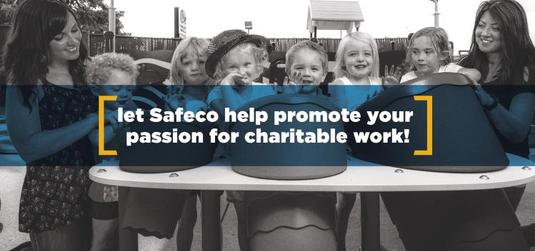

**Stay informed about the latest opportunities from Safeco, and receive timely information about deadlines, tips for great applications, marketing ideas and more.**



Send an email to

**MakeMoreHappenAward@Safeco.com**

**Questions?**   
**Contact Alexis Holzer  
Program Manager, Agent Giving**

Alexis.Holzer@Safeco.com

www.AgentGiving.com

1. 2016 Edelman Barometer
2. Cone Communication 2017 CSR Study