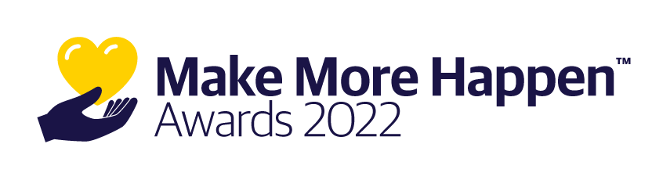

CONFIDENTIAL INFORMATION. DO NOT DISTRIBUTE.
For agent-facing employees, not for external distribution
2022 Make More Happen Awards
Affected states: Nationwide
Overview:
Liberty Mutual and Safeco’s Agent Giving Program is aimed at encouraging agents to give back to nonprofits in their community and rewarding them for their effort and positive impact. Find your resources at www.AgentGiving.com/territory-manager-resources.

Key messages for agents
- Amplify the charitable work you do in your community, however big or small. In 2022, Liberty Mutual/Safeco is awarding $375,000 on behalf of independent agents who make their communities a better place.
- The Make More Happen™ Awards award donations of up to $10,000 for the partner nonprofit of your choice, plus resources and programs to help you grow community awareness of the nonprofit and your part in giving back.
Details: 2022 changes and program details
- There are two changes to the program in response to agent feedback:
  - Starting an application is easier than ever. With a pre-screen application, we will ensure that your nominated nonprofit meets the program giving guidelines before you spend time filling out a full application.
  - Applications will be accepted, and awards will be made on a rolling basis to provide you the greatest flexibility to apply, when it makes sense for your agency.
    - Pre-application is available Feb. 28, 2022 – Aug. 1, 2022. This part will take approximately 10 minutes to complete, saving your valuable time. Applications that pass the pre-screen will be invited to complete the full application.
    - Full application is available March 28, 2022 – Sept. 2, 2022. This application is also shorter that in years past. See the application questions here.
    - Awards will be made on a monthly basis.
    - Applying early will give you the greatest chance of winning as eligible and completed full applications are kept under consideration until the end of the program.
- The application includes questions about how the applicant continued to support the nonprofit throughout the COVID-19 pandemic. We know that it continues to be challenging for agents to be “hands-on”, but we would like to see how they got creative in their efforts to support the nonprofit.
- Agents must submit three photos with their application.
- Once an agent is selected for an award, a $5,000 donation is earmarked for the nonprofit, and it’s up to the team to share their story on social media and get people to leave comments on their story. They must receive a combined 500 shares and comments to receive the full $10,000 award.

Details: Resources

Agent resources are available on www.AgentGiving.com/agent-resources, including:
- Guide to Community Engagement – why it’s important to give back, how to get started, how to talk about and promote your good work and how to apply for our donation programs
- Helpful photo and caption tips
- Make More Happen application questions and guide
- 2022 Make More Happen Official Rules

Communication to agents (planned)
- Feb. 28: Email communication about Make More Happen to all BL/PL agents to announce the pre-application
- March 28: email to agents (targeted) to announce full application open / reminder to apply
- Safeco Agent News and Newsbrief: March 1
- Weekly social media posts on all LMI small commercial and Safeco channels and regional LinkedIn groups.

Questions? Contact Alexis Holzer, Program Manager for Agent Giving at alexis.holzer@safeco.com.

